**Analysis of the results:**

**Conclude the model based on the following verifications:**

1. Select significant variables based on the individual p values. The p values should be less than significance level required.
2. Check the p values for H&L test. It should be higher than 0.05 for a good model



1. See the concordance value. Use the c value to calculate the Gini Coefficient. A good model should have Gini coefficient of 60-80%.

Gini coefficient = 2C -1



Include the lift curve to highlight the gain from the model over the base case.

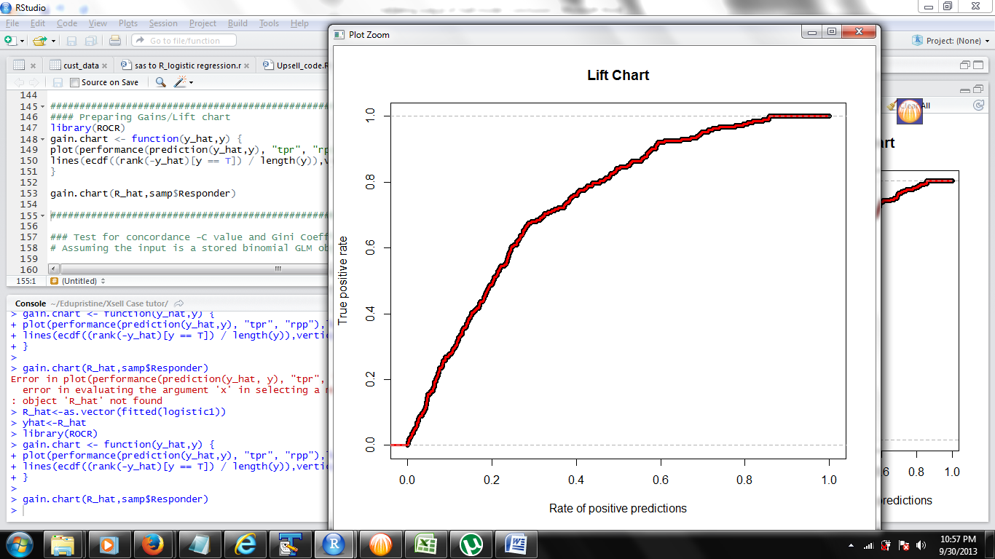

Application of the model

Use the significant coefficient to predict the future customers to get their propensity score using the basic equation of logistic equation.

P = ez/1+ez where z is linear form of equation with coefficients.